## **PURPOSE**



**BIOFIRE® FILMARRAY® Tropical Fever** (**TF**) **Panel Testing**

This procedure provides instructions for testing human whole blood in EDTA tubes using the BIOFIRE

FILMARRAY Tropical Fever (TF) Panel Kit.

## **BACKGROUND**

The BIOFIRE FILMARRAY TF Panel is a polymerase chain reaction (PCR) based test that simultaneously identifies six bacterial, viral, and parasitic pathogens from human whole blood in EDTA tubes collected from individuals with signs and/or symptoms of acute febrile illness or recent acute febrile illness and known or suspected exposure to the target pathogens (Table 1) in about 50 minutes1.

The following organisms are identified using the BIOFIRE FILMARRAY TF Panel:

|  |  |
| --- | --- |
| **Type** | **Organism** |
| **Bacteria** | *Leptospira* spp. |
| **Viruses** | Chikungunya virus |
| Dengue virus (serotypes 1, 2, 3 and 4) |
| **Parasites** | *Plasmodium* spp. |
| *Plasmodium falciparum* |
| *Plasmodium vivax/ovale* |

## **PRINCIPLE OF THE PROCEDURE**

The BIOFIRE® FILMARRAY® TF Panel pouch is a closed system disposable that stores all the necessary reagents for sample preparation, reverse transcription, PCR, and detection to isolate, amplify, and detect nucleic acid from multiple pathogens within a single human whole blood specimen. After sample collection, the user injects hydration solution and sample combined with Sample Buffer into the pouch, places the pouch into the BIOFIRE® FILMARRAY® System, and starts a run. The entire run process takes about 50 minutes. Additional details can be found in the appropriate BIOFIRE® System Operator’s Manual.

During a run, the BIOFIRE System:

* Lyses the sample by agitation (bead beating) in addition to chemical lysis mediated by the Sample Buffer.
* Extracts and purifies all nucleic acids from the sample using magnetic bead technology.
* Performs nested multiplex PCR by:
  + First performing reverse transcription, followed by a multiplexed first stage PCR reaction (PCR1).
  + Then performing multiple simultaneous second-stage PCR reactions (PCR2) in the array to amplify sequences within the PCR1 products.
* Uses endpoint melting curve data to detect and generate a result for each target on the BIOFIRE FILMARRAY TF Panel.

## **SAMPLE REQUIREMENTS**

The following table describes the requirements for specimen collection, preparation, and handling that will help ensure accurate test results.

|  |  |
| --- | --- |
| **Specimen Type** | Human Whole Blood collected in EDTA tubes |
| **Minimum Sample Volume** | ~0.2 mL (200 µL) |
| **Transport and Storage** | Specimens should be tested with the BIOFIRE FILMARRAY TF Panel as soon as possiblea. If transport or storage is required, specimens can be held:   * At room temperature for up to 1 day (15-30 °C) * Refrigerated for up to 7 days (2-8 °C) |

a Specimens should not be centrifuged before testing. Bleach can damage organisms/nucleic acids within the specimen, potentially causing false negative results. Contact between bleach and specimens during collection, disinfection, and testing procedures should be avoided.

**REAGENT STORAGE, HANDLING, AND STABILITY**

* All kit components should be stored and used together at room temperature (18-30 °C), including reagent pouches and buffers. Do not use components from one kit with those of another kit. **DO NOT REFRIGERATE.**
* Avoid storage of any materials near heating or cooling vents or in direct sunlight.
* Always check the expiration date on the kit. Do not use reagents beyond the expiration date printed on the pouch or kit.
* Do not remove pouches from their packaging until a sample is ready to be tested. Once the pouch packaging has been opened, the pouch should be loaded as soon as possible (within approximately 30 minutes).
* Once a pouch has been loaded, the test run should be started as soon as possible (within approximately 60 minutes). Do not expose a loaded pouch to temperatures above 40 °C (104 °F) prior to testing.

## **MATERIALS**

The following table describes the requirements for specimen collection, preparation, and handling that will help ensure accurate test results.

|  |  |
| --- | --- |
| **MATERIALS PROVIDED** | **MATERIALS REQUIRED BUT NOT PROVIDED** |
| Each kit contains sufficient reagents to test 6 samples (6-test kit; Material Number -424803):   * Individually packaged BIOFIRE® FILMARRAY® TF Panel pouches * Single-use (1mL) Sample Buffer ampoules * Single-use pre-filled (1.5mL) Hydration Injection Vials (blue) * Single-use Sample Injection Vials (red) * Individually packaged Transfer Pipettes * BIOFIRE FILMARRAY Tropical Fever (TF) Panel Software | BIOFIRE® System including:   * BIOFIRE® 2.0 or BIOFIRE® TORCH and accompanying system-specific core software * BIOFIRE® FILMARRAY® Pouch Loading * Station 10% bleach solution or a similar disinfectant |

**QUALITY CONTROL**

# PROCESS CONTROL

Two process controls are included in each pouch:

# DNA PROCESS CONTROL

The DNA Process Control assay targets a DNA transcript from the yeast *Schizosaccharomyces pombe.* The yeast is present in the pouch in a freeze-dried form and becomes rehydrated when sample is loaded. The control material is carried through all stages of the test process, including lysis, nucleic acid purification, PCR1, dilution, PCR2, and DNA melting. A positive control result indicates that all steps carried out in the BIOFIRE FILMARRAY TF Panel pouch were successful.

# PCR2 CONTROL

The PCR2 Control assay detects a DNA target that is dried into wells of the array along with the corresponding primers. A positive result indicates that PCR2 was successful.

Both control assays must be positive for the test run to pass. If the controls fail, the sample should be retested using a new pouch.

## **MONITORING TEST SYSTEM PERFORMANCE**

The BIOFIRE® software will automatically fail the run if the melting temperature (Tm) for either the RNA Process Control or the PCR2 Control is outside of an acceptable range (80.0-84.0°C for the RNA Process Control and 74.0-78.0°C for the PCR2 Control). If required by local, state, or accrediting organization quality control requirements, users can monitor the system by trending Tm values for the control assays and maintaining records according to standard laboratory quality control practices. Refer to the appropriate BIOFIRE® FILMARRAY® System Operator’s Manual for instructions on obtaining control assay Tm values. The PCR2 Control is used in several BIOFIRE pouch types and can, therefore, be used to monitor the system when multiple pouch types are used on the same BIOFIRE System.

## **EXTERNAL CONTROLS**

External controls should be used in accordance with laboratory protocols and the appropriate accrediting organization requirements, as applicable. Previously characterized positive samples or negative samples spiked with well-characterized organisms can be used as external positive controls. Commercial external control materials may be available from other manufacturers; these should be used in accordance with the manufacturers’ instructions and appropriate accrediting organization requirements, as applicable.

## **PROCEDURE**

Use clean gloves and other Personal Protective Equipment (PPE) when handling pouches and samples. Only prepare one BIOFIRE® FILMARRAY® TF Panel pouch at a time and change gloves between samples and pouches. Once sample is added to the pouch, promptly transfer to the instrument to start the run. After the run is complete, discard the pouch in a biohazard container.

## **STEP 1: PREPARE POUCH**



1. Thoroughly clean the work area and the Pouch Loading Station with freshly prepared 10% bleach (or suitable disinfectant) followed by a water rinse.
2. Wearing clean gloves, remove the pouch from its vacuum-sealed package by tearing or cutting the notched outer packaging and opening the protective canister. Use caution when opening the vacuum-sealed package as edges may be sharp.

***NOTE:*** *The pouch may still be used even if the vacuum seal of the pouch is not intact. Attempt to hydrate the pouch using the steps in the Hydrate*

*Pouch section. If hydration is successful, continue with the run. If hydration fails, discard the pouch and use a new pouch to test the sample.*

1. Check the expiration date on the kit. Do not use expired kit components or pouches.
2. Insert the pouch into the Pouch Loading Station, aligning the red and blue labels on the pouch with the red and blue arrows on the Pouch Loading Station.
3. Remove the Sample Injection Vial from its package by tearing or cutting the notched outer packaging. Remove the clear cap from the end of the Sample Injection Vial (red cover). Place the Sample Injection Vial (with red cover) into the red well of the Pouch Loading Station.
4. Place a Hydration Injection Vial (with blue cover) into the blue well of the Pouch Loading Station.

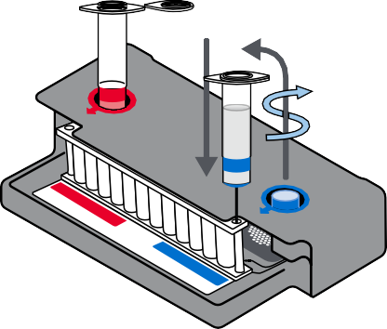

**STEP 2: HYDRATE POUCH**

1. Unscrew **Hydration Injection Vial**, leaving the blue plastic cover in the well of the Pouch Loading Station.
2. Insert the tip of the **Hydration Injection Vial’s** blunt needle into the **pouch hydration port** located directly below the blue arrow of the Pouch Loading Station.
3. Forcefully push down in a firm and quick motion to puncture seal until a faint “pop” is heard and there is an ease in resistance. The correct volume of liquid will be pulled into the pouch automatically.
4. Leave **Hydration Injection Vial** in pouch port.
5. Note: Some hydration solution may remain in the **Hydration Injection Vial.** 
   * If the hydration solution is not automatically drawn into the pouch, repeat Step 2 to verify that the seal of the **pouch hydration port** was broken. If hydration solution is again not drawn into the pouch, discard the current pouch, retrieve a new pouch, and repeat from Step 1: Prepare Pouch.

## **STEP 3: PREPARE SAMPLE MIX**

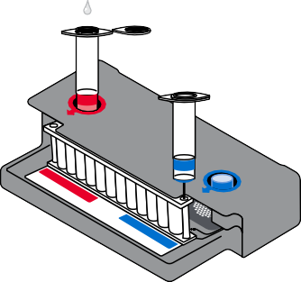

***NOTE:*** *DO NOT use the Transfer Pipette to mix the sample once it is loaded into the Sample Injection Vial* Use the transfer pipette provided in the test kit to draw specimen to the second line (approximately 0.2 mL) of the transfer pipette.

1. Add the specimen to the Sample Buffer in the **Sample Injection Vial.**
2. Discard the Transfer Pipette in a biohazard waste container.
3. Add Sample Buffer to the **Sample Injection Vial** using the following steps:
   * Hold the Sample Buffer ampoule with the tip facing up.

***NOTE:*** *Avoid touching the ampoule tip during handling, as this may introduce contamination.*

* + Firmly pinch at textured plastic tab on the side of the ampoule until the seal snaps.
  + Invert the ampoule over the red-capped Sample Injection Vial and dispense Sample Buffer using a slow, forceful squeeze followed by a second squeeze.

***NOTE:*** *Avoid squeezing the ampoule additional times to avoid foaming.*

**WARNING:** The Sample Buffer is harmful if swallowed and can cause serious eye damage and skin irritation. Use appropriate PPE.

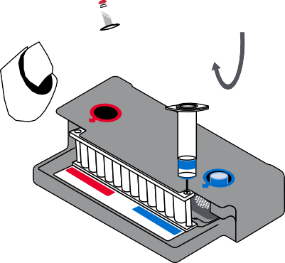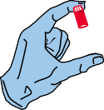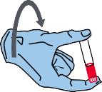

3x

1. Tightly close the lid of the **Sample Injection Vial**.
2. Remove the Sample Injection Vial from the Pouch Loading Station and invert the vial of  
   human whole blood container 3 times until thoroughly mixed.

***NOTE:*** *DO NOT use the Transfer Pipette to mix the sample once it is loaded into the Sample Injection Vial.*

1. Return the **Sample Injection Vial** to the **red well** of the Pouch Loading Station.

## **STEP 4: LOAD PATIENT SAMPLE**

1. Slowly twist to unscrew the **Sample Injection Vial** from the red cap and wait for 5 seconds with the vial resting in the cap.

***NOTE:*** *Waiting 5 seconds decreases the risk of dripping and contamination from the sample.*

1. Lift the **Sample Injection Vial**, leaving red cap in the well of the Pouch Loading Station, and insert the **Sample Injection Vial** cannula tip into the **pouch sample port** located directly below the red arrow of the Pouch Loading Station.
2. Forcefully push down in a firm and quick motion to puncture seal

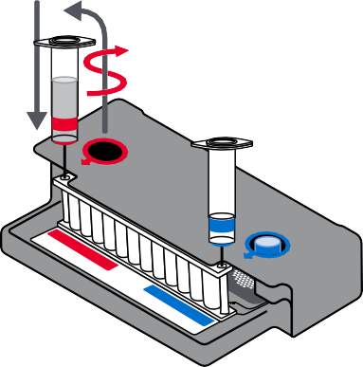

(a faint “pop” is heard) and sample is pulled into the pouch by vacuum.

1. Verify that the sample has been loaded.
   * Flip the barcode label down and check to see that fluid has entered the reagent well next to the sample loading port.
   * If the pouch fails to pull sample from the **Sample Injection Vial**, the pouch should be discarded. Retrieve a new pouch and repeat from Step 1: Prepare Pouch.
2. Discard the **Sample Injection Vial** and the **Hydration Injection Vial**

in appropriate biohazard sharps container.

1. Record the Sample ID in the provided area on the pouch label (or affix a barcoded Sample ID) and remove the pouch from the Pouch Loading Station.

## **STEP 5: START RUN**

The BIOFIRE® Software includes step-by-step, on-screen instructions that guide the operator through performing a run. Refer to the appropriate BIOFIRE® FILMARRAY® System Operator’s Manual for more detailed instructions.

## **BIOFIRE® 2.0**

1. Ensure that the BIOFIRE 2.0 system (instrument and computer) is powered on and the software is launched.
2. Follow on-screen instructions and procedures described in the Operator’s Manual to place the pouch in a module, enter pouch, sample, and operator information.
3. Pouch identification (Lot Number and Serial Number), Pouch Type, and Protocol information will be automatically entered when the barcode is scanned. If it is not possible to scan the barcode, the pouch Lot Number, Serial Number, Pouch Type, and Protocol can be manually entered from the information provided on the pouch label into the appropriate fields. To reduce data entry errors, it is strongly recommended that the pouch information be entered by scanning the barcode.

***NOTE:*** *When selecting a Pouch Type manually, ensure that the Pouch Type matches the label on the BIOFIRE FILMARRAY TF Panel pouch.*

1. Enter the Sample ID. The Sample ID can be entered manually or scanned in by using the barcode scanner when a barcoded Sample ID is used.
2. If necessary, select and/or confirm the appropriate protocol for your sample type from the Protocol drop down list. The BIOFIRE® FILMARRAY® TF Panel has a single protocol available in the drop-down list.
3. Enter a username and password in the Name and Password fields.

***NOTE:*** *The font color of the username is red until the username is recognized by the software.*

1. Review the entered run information on the screen. If correct, select Start Run. Once the run has started, the screen displays a list of the steps being performed by the instrument and the number of minutes remaining in the run.

***NOTE:*** *The bead-beater apparatus makes an audible, high-pitched noise during the first minute of operation.*

1. When the run is finished, follow the on-screen instructions to remove the pouch, then immediately discard it in a biohazard waste container.
2. The run file is automatically saved in the BIOFIRE® Software database, and the test report can be viewed, printed, and/or saved as a PDF file.

## **BIOFIRE® TORCH**

1. Ensure that the BIOFIRE TORCH system is powered on.
2. Select an available Module on the touch screen or scan the barcode on the pouch using the barcode scanner.
3. Pouch identification (Lot Number and Serial Number), Pouch Type, and Protocol information will be automatically entered when the barcode is scanned. If it is not possible to scan the barcode, the pouch Lot Number, Serial Number, Pouch Type, and Protocol can be manually entered from the information provided on the pouch label into the appropriate fields. To reduce data entry errors, it is strongly recommended that the pouch information be entered by scanning the barcode.

***NOTE:*** *When selecting a Pouch Type manually, ensure that the Pouch Type matches the label on the BIOFIRE® FILMARRAY® TF Panel.*

1. Enter the Sample ID. The Sample ID can be entered manually or scanned in by using the barcode scanner when a barcoded Sample ID is used.
2. Insert the pouch into the available Module.
   * Ensure that the pouch fitment label is lying flat on top of pouch and not folded over. As the pouch is inserted, the module will grab onto the pouch and pull it into the chamber.
3. If necessary, select and/or confirm the appropriate protocol for your sample type from the Protocol drop down list. The BIOFIRE FILMARRAY TF Panel has a single protocol available in the drop-down list.
4. Enter operator username and password, then select Next.

***NOTE:*** *The font color of the username is red until the username is recognized by the software.*

1. Review the entered run information on the screen. If correct, select Start Run. Once the run has started the screen displays a list of the steps being performed by the module and the number of minutes remaining in the run.

***NOTE:*** *The bead-beater apparatus can be heard as a high-pitched noise during the first minute of operation.*

1. At the end of the run, remove the partially ejected pouch, then immediately discard it in a biohazard waste container.
2. The run file is automatically saved in the BIOFIRE® Software database, and the test report can be viewed, printed, and/or saved as a PDF file.

## **STEP 6: ASSAY INTERPRETATION**

When PCR2 is complete, the instrument performs a high-resolution DNA melting analysis on the PCR products and records the change in fluorescence signal generated in each well (for more information see appropriate BIOFIRE® System Operator’s Manual). The BIOFIRE Software then performs several analyses and assigns a final assay result. The steps in the analyses are described below.

**Analysis of melt curves.** The BIOFIRE Software evaluates the DNA melt curve for each well of the PCR2 array to determine if a PCR product was present in that well. If the melt profile indicates the presence of a PCR product, then the analysis software calculates the melting temperature (Tm) of the curve and compares it against the expected Tm range for the assay. If the software determines that the Tm value falls inside the assay-specific Tm range, the melt curve is called positive. If the software determines that the melt curve is not in the appropriate Tm range, the melt curve is called negative.

**Analysis of replicates.** Once positive melt curves have been identified, the software evaluates the replicates for each assay to determine the assay result. For an assay to be called positive, two associated melt curves must be called positive, both Tm values must be similar. Assays that do not meet these criteria are called negative.

## **ORGANISM INTERPRETATION**

The reported BIOFIRE® FILMARRAY® TF Panel organism interpretation of results (Detected or Not Detected) may be based on the result of a single assay or on results from a combination of multiple assays, as shown in Table 2.

In cases where either or both of the internal process control assays have failed, all analyte results are Invalid and are not reported. Nationally notifiable results are to be reported to public health authorities in accordance with local, state, and federal law. In the United States, when Detected, all the pathogens on this panel must be reported to the Centers for Disease Control and Prevention.

**Table 2. Assay Number and Interpretation Rules for the BIOFIRE FILMARRAY TF Panel**

|  |  |  |
| --- | --- | --- |
| **Organism** | **No. of Assays** | **Assay Interpretation Rules** |
| **BACTERIA** | | |
| *Leptospira* spp. | 1 | Positive = Detected |
| **VIRUSES** | | |
| Chikungunya virus | 2 | Any Positive = Detected |
| Dengue virusa | 5 | Any Positive = Detected |
| **PARASITES** | | |
| *Plasmodium* spp. | 3 | Any Positive = Detected |
| *Plasmodium falciparum* | 1 | Positive = Detected |
| *Plasmodium vivax/ovale* | b  1 | Positive = Detected |

a. The BIOFIRE FILMARRAY TF Panel contains multiple assays for the detection of the dengue virus serotypes. See dengue virus reporting section below for more information.

b. The BIOFIRE FILMARRAY TF Panel contains one multiplexed assay for the detection of both *Plasmodium vivax* and

*Plasmodium ovale*, which is reported with a single interpretation call.

## **RESULT INTERPRETATION**

**Leptospira spp. Reporting**

The BIOFIRE FILMARRAY TF Panel contains a single pan assay for genus-level detection of all *Leptospira* Group 1 species. A positive *Leptospira* pan assay will result in a Detected call for Leptospira spp.

### **Chikungunya virus Reporting**

The BIOFIRE FILMARRAY TF Panel contains two assays for species-level detection of all Chikungunya virus strains. Any positive Chikungunya virus assay(s) will result in a Detected call for Chikungunya virus.

### **Dengue virus Reporting**

### The BIOFIRE FILMARRAY TF Panel contains five assays for the detection of the four Dengue virus serotypes. Any positive Dengue virus assay(s) will result in a Detected call for Dengue virus.

### **Plasmodium Reporting**

The BIOFIRE® FILMARRAY® TF Panel contains three Plasmodium assays, one genus-level assay and two species- level assays. The genus-level assay (*Plasmodium* spp. assay) detects Plasmodium species including the five Plasmodium species known to infect humans (*P. falciparum, P. vivax, P. ovale, P. malariae*, and *P. knowlesi*). One species-level assay detects *Plasmodium falciparum*, and a combined species-level assay detects *Plasmodium vivax* and *Plasmodium ovale*. Table 3 shows the reporting scheme for the three Plasmodium assays. This test cannot differentiate co-infections other than *Plasmodium falciparum* and *Plasmodium vivax/ovale*. Infection with additional Plasmodium species is always possible and should be considered.

#### Caution: Before consideration of treatment for the hypnozoite liver form, confirm the presence of a **P. vivax or P. ovale infection.**

* **Table 3. Plasmodium Report Scheme**

|  |  |  |  |
| --- | --- | --- | --- |
| **Assay Detection Outcomes** | | | **Plasmodium Organism Results** |
| ***Plasmodium***  **spp.** | ***Plasmodium falciparum*** | ***Plasmodium vivax/ovale*** |
| Negative | Negative | Negative | *Plasmodium* spp. Not Detected  *Plasmodium falciparum* Not Detected  *Plasmodium vivax/ovale* Not Detected |
| **Positive** | Negative | Negative | *Plasmodium* spp. Detected  *Plasmodium falciparum* Not Detected  *Plasmodium vivax/ovale* Not Detected |
| **Positive** | **Positive** | Negative | *Plasmodium* spp. Detected  *Plasmodium falciparum* Detected  *Plasmodium vivax/ovale* Not Detected |
| **Positive** | Negative | **Positive** | *Plasmodium* spp. Detected  *Plasmodium falciparum* Not Detected  *Plasmodium vivax/ovale* Detected |
| **Positive** | **Positive** | **Positive** | *Plasmodium* spp. Detected  *Plasmodium falciparum* Detected  *Plasmodium vivax/ovale* Detected |

## **BIOFIRE® FILMARRAY® Tropical Fever (TF) PANEL TEST REPORT**

The BIOFIRE FILMARRAY TF Panel test report (Figure 1) is automatically displayed upon completion of a run and can be saved as a PDF file or printed. Each report contains Run Summary, a Result Summary section, and a Run Details section.

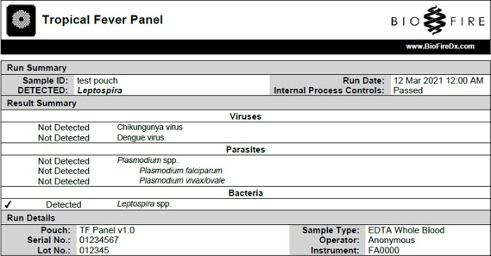**Figure 1**

## **RUN SUMMARY**

The Run Summary section of the test report is displayed at the top of the page. This section provides information about the run including Sample ID, Run Date, Internal Process Control results, and a Result Banner. Internal Process Control results are reported as Passed, Failed, or Invalid. The Result Banner lists a summary of the test outcome/results and any required notes/actions associated with those results. If there are Detected results, the Result Banner will display a relevant summary of those results. If there are no Detected results, the Result Banner will display No Detections. If the results are invalid for any reason, the Result Banner will display INVALID: along with the Run Status (Incomplete, Aborted, Instrument Error, Software Error, or Internal Process Control Failure). The Result Banner shall also display any notes/actions associated with the results obtained, if applicable.

Table 4 provides additional information for each of the possible internal process control field results.

**Table 4. Interpretation of Internal Process Controls Field on the BIOFIRE® FILMARRAY® TF Panel Test Report**

|  |  |  |
| --- | --- | --- |
| **Internal Process Control Results** | **Explanation** | **Action Required** |
| Passed | The run was successfully completed AND  Both internal process controls (RNA Process Control and PCR2 Control) were successful. | Follow any instructions provided in the Result Banner. |
| Failed | The run was successfully completed AND  At least one of the internal process controls (RNA Process Control and/or PCR2 Control) failed. | Follow any instructions provided in the Result Banner. |
| Invalid | The internal process controls are invalid because the run did not complete.  (Typically this indicates a software or hardware error.) | Note any error codes displayed by the software during the run. Refer to the appropriate BioFire FilmArray operator’s manual or call Technical Support for further instruction.  If the error can be resolved, repeat the test once using a new pouch. |

## **RESULT SUMMARY**

The Result Summary section provides a complete list of all test results. Possible results include Detected or Not Detected. Table 5 provides an explanation for each interpretation and any follow-up necessary to obtain a final result.

**Table 5. Interpretation of Results on the BIOFIRE FILMARRAY TF Panel Test Report**

|  |  |  |
| --- | --- | --- |
| **Results** | **Explanation** | **Report** |
| **Not Detected**  **<Organism Name(s)>** | The run was successfully completed AND the internal process controls were successful (Passed)  AND  All assay(s) for the organism were NEGATIVE | Results are valid. Follow any instructions provided in the Result Banner. |
| **Detected**  **<Organism Name(s)>** | The run was successfully completed AND the internal process controls were successful (Passed)  AND  At least one assay for the organism was POSITIVE | Results are valid. Follow any instructions provided in the Result Banner. |
| **(N/A - Result Summary section does not appear)** | The run was successfully completed AND the internal process controls were not successful (Failed)  OR  Run did not complete | All results are invalid because the run failed. Note any error codes displayed and refer to the appropriate BioFire FilmArray operator’s manual for more information. If the error persists, contact Technical Support for further instruction.  Retest the sample. |

NOTE: Detection of two or more unique pathogens may indicate a possible contamination event. Follow the instructions in the Result Banner for retesting. If the two or more positive results are not duplicated, contact bioMérieux Technical Support and discontinue testing until the test area has been decontaminated.

## **RUN DETAILS**

The Run Details section provides additional information about the run, including pouch information (type, lot number, and serial number), Run Status (Completed, Incomplete, Aborted, Instrument Error, or Software Error), the protocol that was used to perform the test, the identity of the operator that performed the test, and the instrument used to perform the test.

## **CHANGE SUMMARY**

It is possible to edit the Sample ID once a run has completed. If this information has been changed, an additional section called Change Summary will be added to the test report. This Change Summary section lists the field that was changed, the revised entry, the original entry, the operator that made the change, and the date that the change was made (Figure 2). Sample ID is the only field of the report that can be changed.

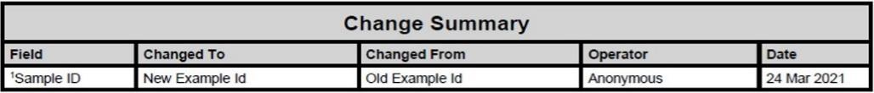**Figure 2. Change Summary Field**

## **REFERENCES/RELATED DOCUMENTS**

1. BIOFIRE® FILMARRAY® Tropical Fever Panel Instructions for Use, (BFR0001-0957), bioMérieux, Inc.